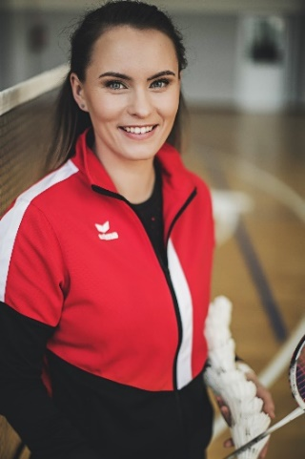 | PERSONAL INFORMATION  Vaida Slušnienė  Lithuania  Birth date: 1993-01-13  Email: slusniene.vaida@gmail.com  Phone no: +370 623 75683  Instagram: @badmintono_trenere_vaida

ABOUT ME
Master‘s degree in physical activity and sports education with 6+ years experience as a badminton coach and 9+ years of experience as a semi professional badminton player. International coaching experience in BWF/BEC projects: the BWF/BEC Coach Education Level 1 Course taken in Luxemburg (2022), RSL BEC Summer School 2022, BE regional project of the Baltic countries (U15 preparation for 2022 European Championship). Currently working at „Palanga city sports centre“ and „Kretinga city sports school“ as a badminton coach and also owner/coach off badminton club „Smešas“. Coaching 4 Lithuania elite players over 16 age and many youth players. Member of Lithuanian badminton federation executive committee. Badminton is my family religion – my husband is a former Lithuania national team player with more than 20+ years of international experience.

EXPERIENCE
- RSL BEC 2022 Summer School staff coach in Finland.
- Regional project of the Baltic countries staff coach organized by BEC and Latvia badminton federation.
- Lithuanian badminton federation U15 team manager in 2022 EU U15 Championship.
- Lithuanian badminton federation executive committee member responsible for kids badminton development in Lithuania.
- 6+ years of experience as a badminton coach.
- 9+ years of experience as a semi professional badminton player.
- Winner of multiple national tournaments in different categories: twice XD vice champion of Lithuania National championship (2018, 2022), 3rd place WD in Lithuania National championship 2022.
- Participated in multiple international tournaments.
- Currently ranked in the Top 3 Lithuanian XD Badminton players rankings.

EDUCATION
Completed Level 1 BWF Coach education (2022-05-08)

Degrees:
- Physical activity and sports education master I 2020-2022 I Klaipėda University
- Business management master I 2016-2018 I Klaipėda University
- Biotechnology bachelor I 2012-2016 I Vytautas Magnus University

Completed sport seminars:
- „From technique to tactics. Introduction to BWF Level 2 coach education“ seminar (2018-11-30)
- „Long-term training planning. Theoretical and practical aspects“ seminar (2018-12-16)
- „Innovations in effective coaching for children, adults and seniors“ seminar (2020-11-23)
- „Stretching physiology, stretching methods. Body & Mind direction in the training process“ seminar (2022-03-05)
- „Optimal warmup and cooldown“ seminar (2022-03-23)

